Danny Idukundatwese
Reg No: 2405001032
Question 1. Pandas DataFrame
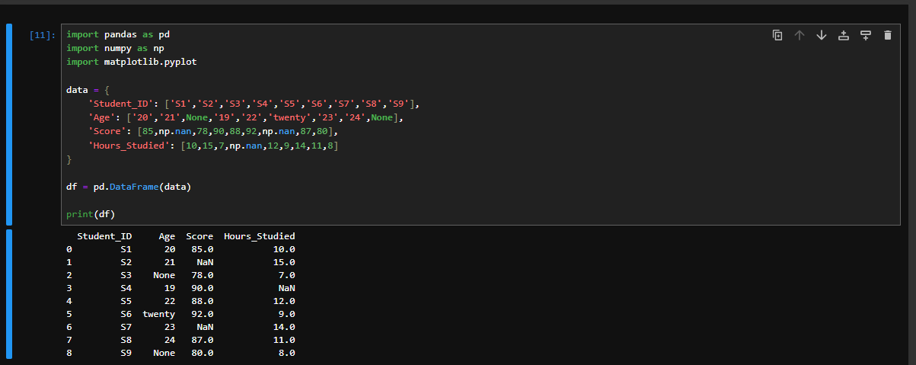
Question 2. Dataset and contents summary
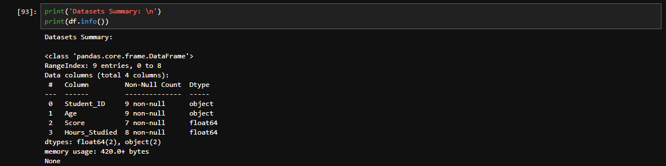
Question 3. Missing Data Summary
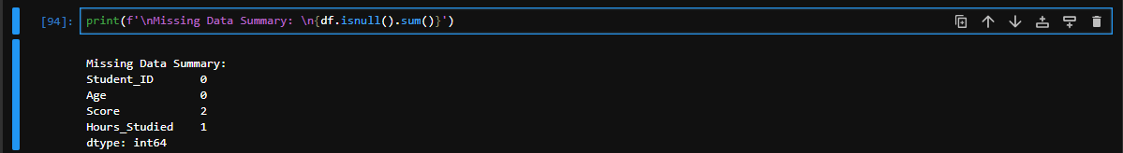
Question 4. Converting Age and Score columns
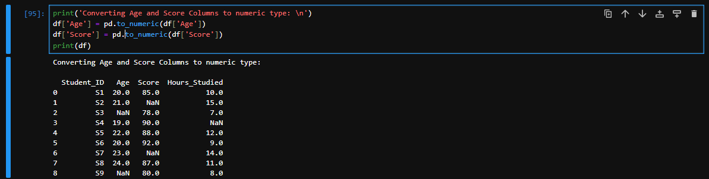
Question 5. Treating all the Missing Data
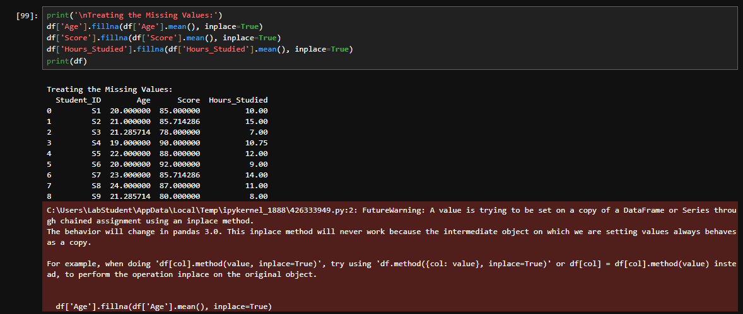
Question 6. Plot a scatter plot
